**Part 1 – Two Data Diagrams**

Table 1 Human Resources Department

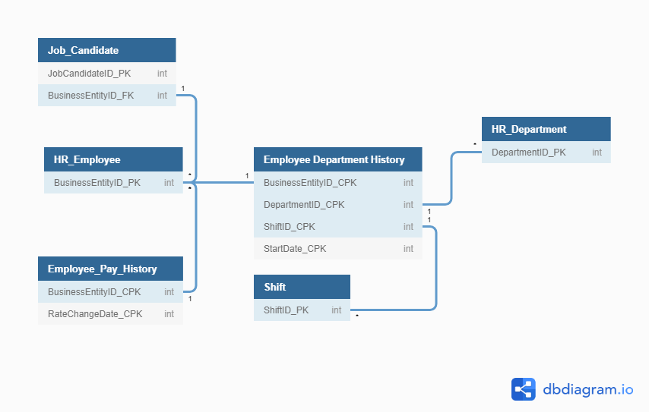

Table 2 Purchasing Data Dictionary

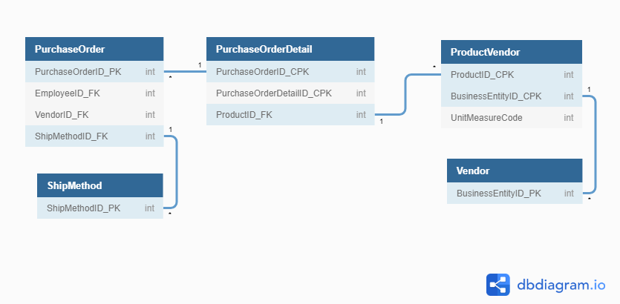

**Part 2 -**

1. **Sales Orders Database relationship of tables in words. Be sure to describe both directions of each link.**

Customer and Employee table convey nearly identical information, but they are bother needed in the Orders table because a customer can have many orders, and in a similar respect an employee could have many orders as well, and the employee involved with the customer’s order in the Orders table invokes their relationship in the database.

Order_Details is an optional table, and a linking table, it links Products and Orders tables to define which products have been ordered by the employee/customers.

The products table can be further broken down with the Categories table, but this table is optional and not reliant on any other table other than the Products table.

Product vendors is anther linking table with CPK ProductNumber coming from Products table, and another CPK with VendorID coming from Vendors table, showing which vendor supplied which product(s).

Lastly the vendors table is a stand-alone table detailing only vendor information.

1. **Table: Employee**

Primary Key: Employee_ID

Composite Keys:

Foreign Keys:

**Table: Certified**

Primary Key:

Composite Keys: Employee_ID, Skill_ID

Foreign Keys:

**Table: Skill**

Primary Key: Skill_ID

Composite Keys:

Foreign Keys:

1. **Put into words the relationship of the tables from question # 2.**

There is a linking table between Skills and Employees. Each employee can have a single skill or multiple skills. It resolves a many-to-many relationship because there are multiple employees with differing degree of skills. The “Certified” table rectifys the many-to-many by displaying the Employee ID, and the Skill ID as a Composite Key, and give descriptions of each skill and date acquired.

1. **Table: Course**

Primary Key: CRS_CODE

Composite Keys:

Foreign Keys: DEPT_CODE

**Table: Class**

Primary Key: CLASS_CODE

Composite Keys:

Foreign Keys: CRS_CODE

1. **Table: Student**

Primary Key: STU_NUM

Composite Keys:

Foreign Keys:

**Table: Enroll**

Primary Key:

Composite Keys: CLASS_CODE, STU_NUM

Foreign Keys:

**Table: Class**

Primary Key: CLASS_CODE

Composite Keys:

Foreign Keys:

1. **Table: Customer**

Primary Key: CUS_CODE

Composite Keys:

Foreign Keys:

**Table: Invoice_Header**

Primary Key:

Composite Keys: INV_NUMBER, CUS_CODE

Foreign Keys:

**Table: Invoice_Detail**

Primary Key: INV_NUMBER

Composite Keys:

Foreign Keys: PROD_CODE

**Table: Products**

Primary Key: PROD_CODE

Composite Keys:

Foreign Keys:

1. **Table: Pilots**

Primary Key: PilotID

Composite Keys:

Foreign Keys:

**Table: Pilot_Certifications**

Primary Key: CertificationID

Composite Keys:

Foreign Keys:

**Table: Certifications**

Primary Key:

Composite Keys: PilotID, CertificationID

Foreign Keys:

1. **Put into words the relationship of the tables from question # 7.**

Pilot table lists details about individual pilots, the certification table ID’s different aircraft certifications. The two tables are united with Pilot_Certifications with PilotID being the primary key to identify with pilot is able to fly which planes via identification from the Certification table.

1. **Table: Employee**

Primary Key: EmployeeID

Composite Keys:

Foreign Keys:

**Table: Department**

Primary Key: DepartmentID

Composite Keys:

Foreign Keys:

**Table: Department_Employees**

Primary Key:

Composite Keys: EmployeeID, DepartmentID

Foreign Keys:

1. **Put into words the relationship of the tables from question # 9.**

Similar to the pilot table above, every employee has details assigned to the primary EmployeeID. The Departments are also detailed in another table. They are brought together in the Department_Employee table organized by employee numbers. It details which department they belong to, and further elaborates on their position in the department.